CN Lab
Experiment-7: Configuration of ARP and DHCP in Cisco packet tracer and verify the configuration
L.Ishitha
2420030041
Sec 5
Steps:
- Open cisco workspace and place 10 PCs, a switch and a router. Connect all of them.
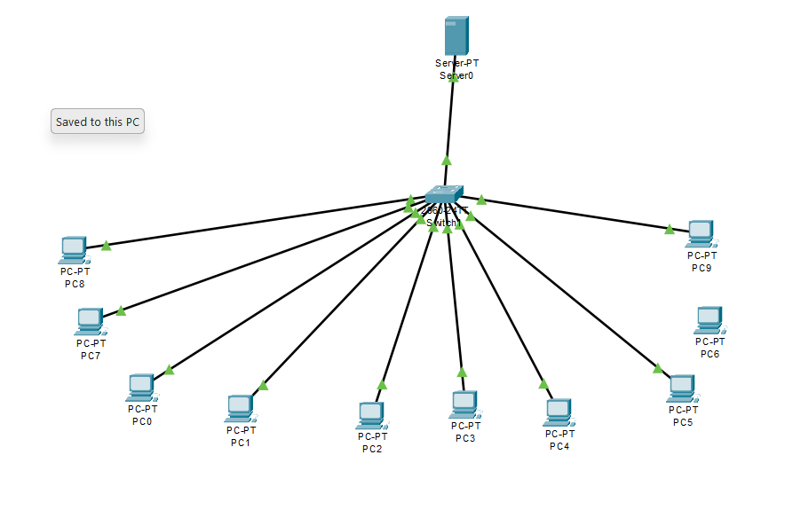
- In server, select DHCP and add IP address setup. Give the starting IP address and subnet mask and click on add.
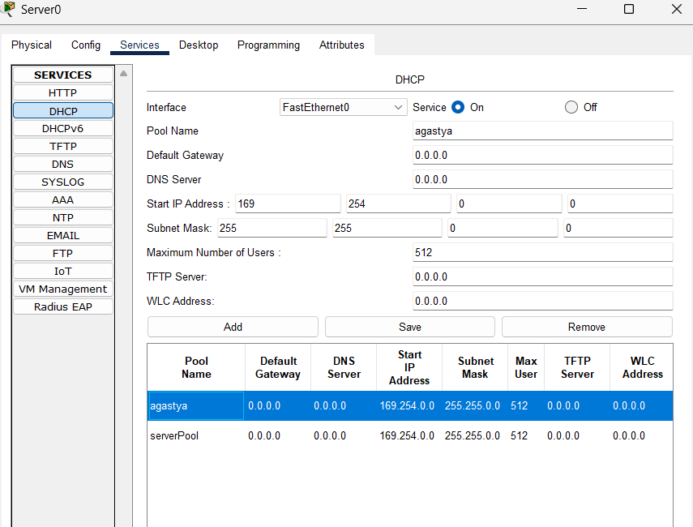
- Assign IP addresses by selecting DHCP in each PC.
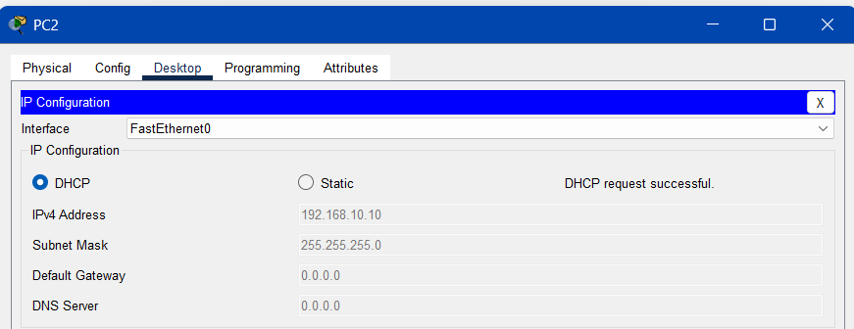
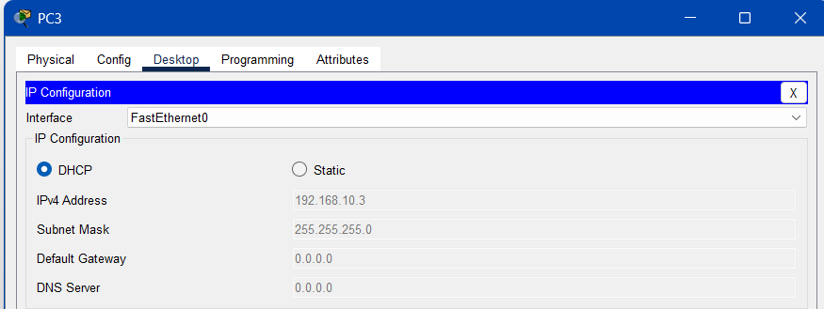
- In simulation mode, assign packets to any two PCs. Observe multicasting and unicasting.
- Check ARP tables.
